
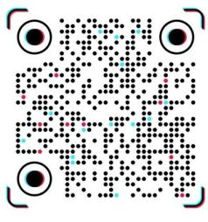 Ultrasound abdomen report
Pateint Name: Uzair khan Age: 29 years Date: 8-10-2026

LIVER
Normal in size with normal parenchymal echogenicity. No focal lesion seen. Normal CBD.

GALL BLADDER
Normal in size with normal wall thickness. No calculus seen.

PANCREASE
Obscured.

SPLEEN
Normal in size and echogenicity.

KIDNEYS
Both kidneys are normal in size with normal cortical thickness and parenchymal echogenicity. CMD is preserved. No cyst, mass, calculus or hydronephrosis seen.

URINARY BLADDER
Adequately filled with normal wall thickness. No mass or calculus seen.

GENERAL ABDOMEN
No ascites seen.

PROSTATE
Normal in size and morphology

IMPRESSION.
Normal abdomen ultrasound study.

 MUHAMMAD MEDICAL COMPLEX PHASE 5 HAYATABAD PESHAWAR
Not valid for legal purpose

